Game Design Document

Fill up the following document

1. Write the title of your project.

wonderkinder

1. What is the goal of the game?

To otivate children to learn more in a fun way

1. Write a brief story of your game.

Sai is a girl

She wants to learn numbers

She finds it difficult as she is confused with the ascending and descending order

This game will help her

1. Which are the playing characters of this game?

* Playing characters are the ones who respond to the user based on the input from the user.
* Cars, monkeys, dinos, wizards, etc., are the playing characters in the game.

|  |  |  |
| --- | --- | --- |
| Number | Character Name | What can this character do? |
| 1 | kitten | Collects correct no of fruits |
| 2 | Rabbit | Jumps when the ascending order is correctly filled |
| 3 | squirrel | Jumps when the descending order is correctly filled |
| 4 |  |  |
| 5 |  |  |
| 6 |  |  |
| 7 |  |  |
| 8 |  |  |

1. Which are the Non-Playing Characters of this game?

* Non-Playing characters are the ones that don't have an action or behavior when the user interacts with the game.
* Hurdles, stones, bananas, coins, etc., are non-playing characters in the game.

|  |  |  |
| --- | --- | --- |
| Number | Character Name | What can this character do? |
| 1 | duck | Encourages the player |
| 2 | Bear | Eats the rabbit if it didnt Jumps when the ascending order is correctly filled |
| 3 | tiger | Eats the squirrel if it didnt Jumps when the descending order is correctly filled |
| 4 |  |  |
| 5 |  |  |
| 6 |  |  |
| 7 |  |  |
| 8 |  |  |

Draw your imagination of this game. What does this game look like?

* Draw the game either on your computer or on paper.
* Add images of the game scenes to show each of the playing and non-playing characters at least once.

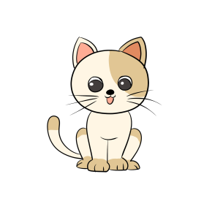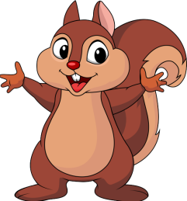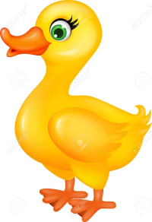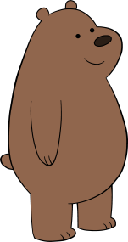

How do you plan to make your game engaging?

by increasing the difficulty level like incresing the digits of the number

Or by setting a time for the player to guess and fill the answer cporrectly

Or by adding a definite aount of lives or decreasing the lives